Balsa Limbo – Limbo Bar Construction Guidelines
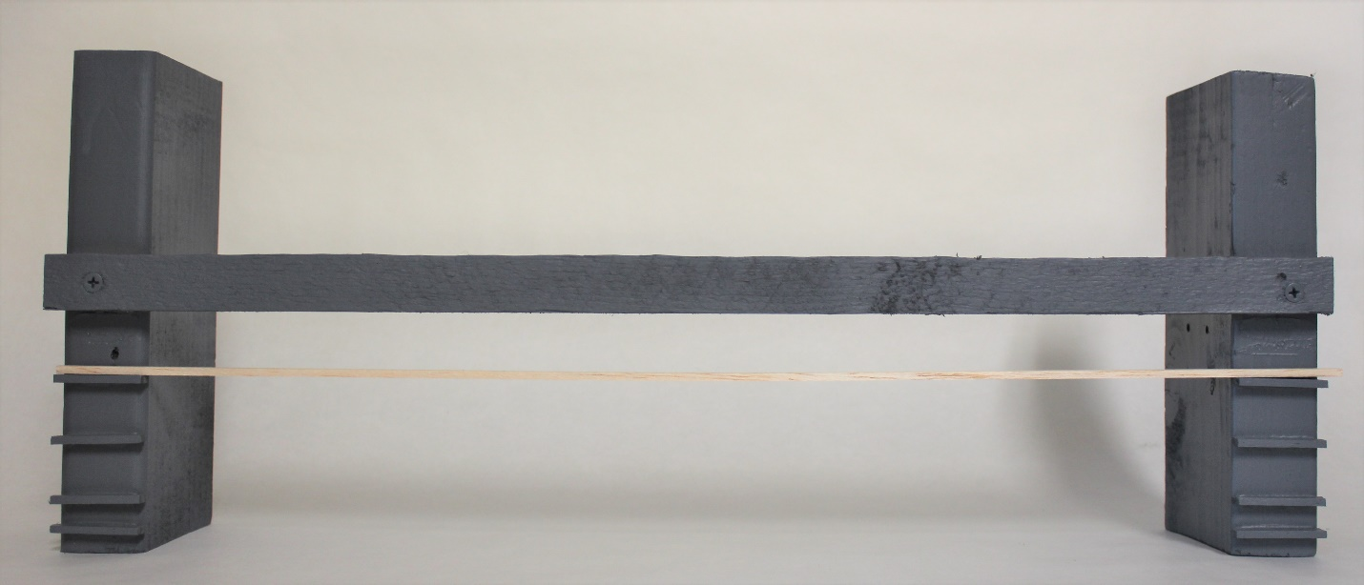
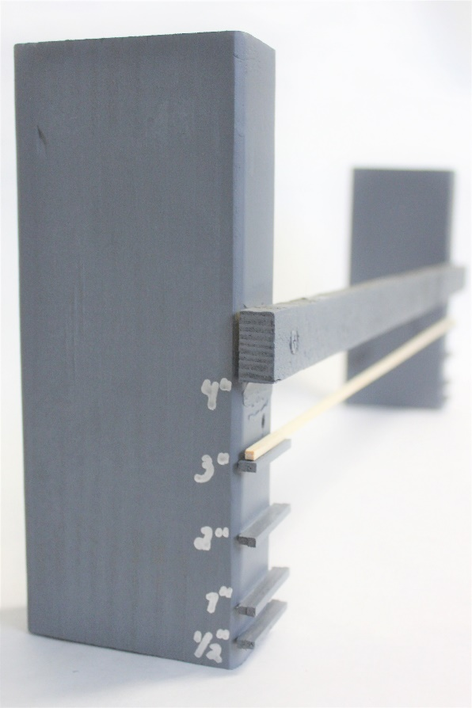
Construction of the fixture for limbo testing can and should be kept as simple as possible.
  - Two vertically oriented pieces of 2x4 lumber, cut to a roughly 6” height, positioned 18” apart at their closest points.
  - A fixed wooden cross piece that connects the two vertical 2x4 pieces and maintains the 18” width. This cross piece can also serve as the “bar” for the maximum height of 4”.
  - Note that the lowest edge of the cross piece should be positioned at a height of 4”.
  - Each vertical 2x4 piece should have 4 ledges, upon which the moveable limbo bar will be positioned.
    - The upper edges of these ledges should be set at the heights of ½”, 1”, 2”, and 3”. (see left image)
    - Ledges should have a depth of at least ¼” to allow the limbo bar to reliably rest on the ledge but also remain easy to knock off, if the structure exceeds the selected height
    - These can be made as simply as a piece of balsa wood glued or otherwise fastened onto the vertical 2x4.

- A straight and sturdy piece of balsa can serve as the actual limbo bar, which will be knocked if the structure exceeds the selected height.
  - Balsa is affordable, readily available, and light enough to be moved by a structure that violates the chosen height limit
  - If using balsa, be sure to have enough extra on hand in case the pieces used in structure testing are damaged.
  - Small aluminum “angle iron,” available at hobby and craft stores, is another option for the moveable limbo bar. This would be less prone to damage or flexing.

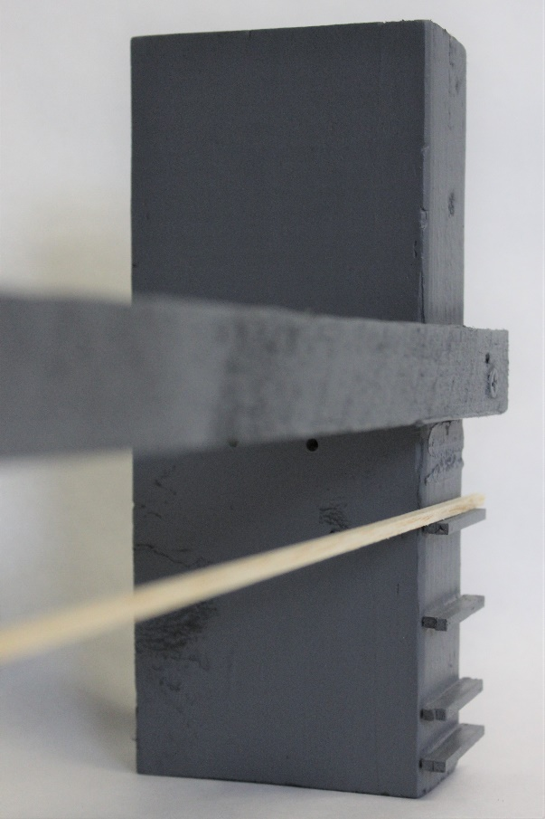
When passing a structure under the limbo bar, the structure should move from the “open” side of the structure, toward the side with the crosspiece and the moveable bar. Moving the structure in this direction will allow the bar to be knocked if the structure exceeds the selected height.
(see right image)

